Choice Based Lettings
A guide to choosing a home through the council


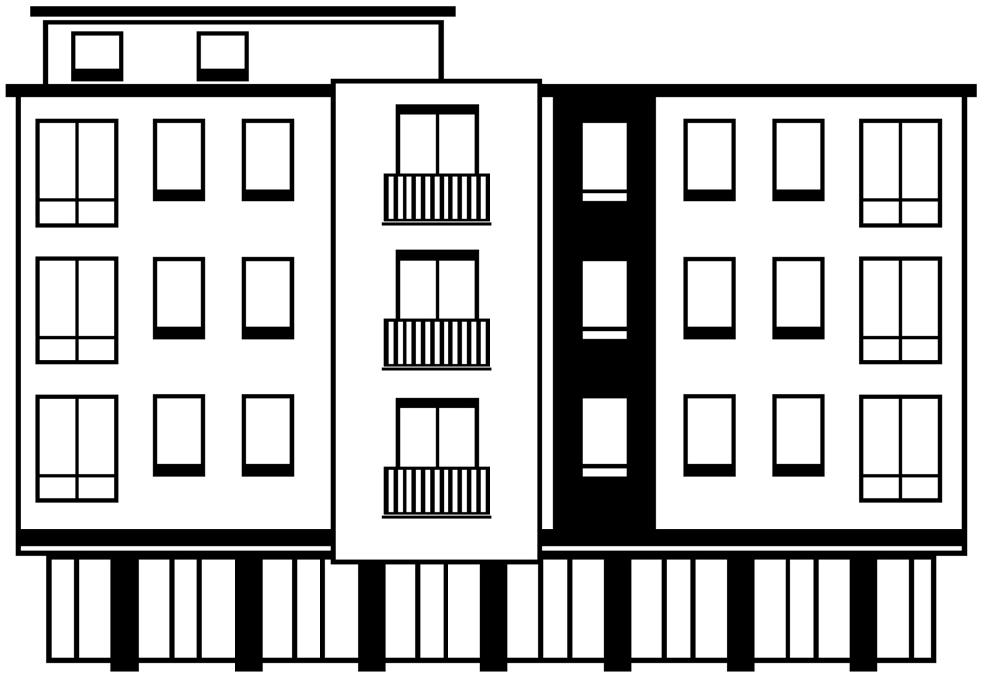





- This guide is for people with a learning disability, families and supporters.

- This guide tells you about how to get a home using Choice Based Lettings

What is Choice Based Lettings?
 | Choice Based Lettings is a new way to rent a home from the council and some housing associations  The old way of renting a home meant that you applied for a home and you stayed on a waiting list until you were offered one  Choice Based Lettings is different. Homes are advertised on the internet and in a newspaper like an estate agent  You choose the homes you are interested in – this is called bidding  Different councils run schemes a little bit differently to each other
How does Choice Based Lettings work?
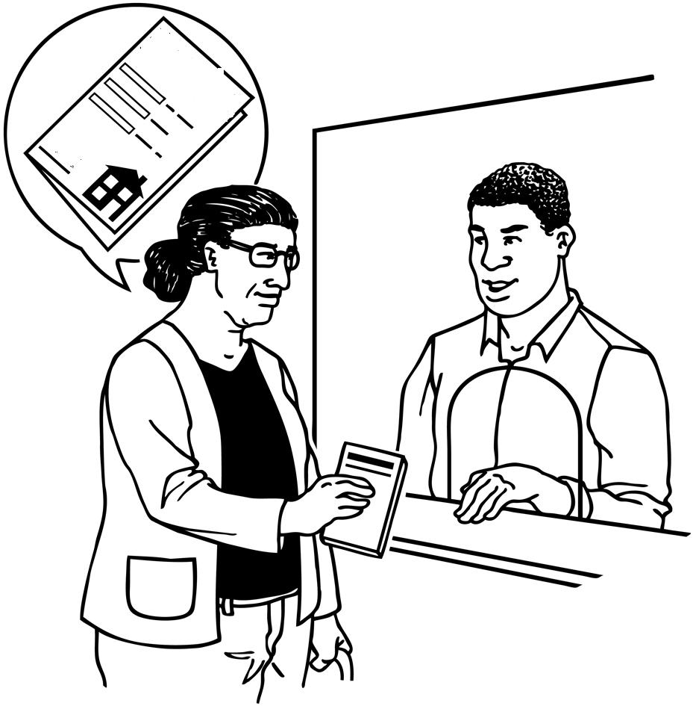 | You will need to apply  You will need say what type of home you are looking for and the area you want  You will need to say why you need to move out of the home you have now  Your doctor, social worker or someone who knows you well may need to give more information
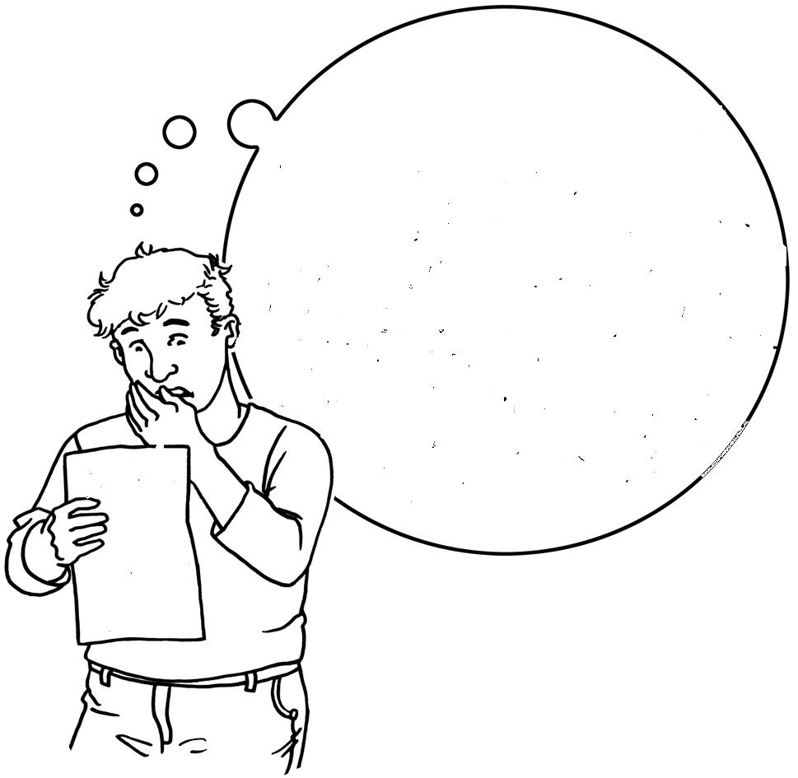    ABCD  D | Find out which band you are in  A band is a group of people who have a similar need for a home.  The bands may the letters A B C D or the numbers 1,2,3,4  The band you are given says how much you need a new home.  Band A = people needing a new home the most, like homeless people  BAND  A  B  C  D  Band B = people needing a new home quickly  Band C = people who need a new home but can wait  Band D = people who need a home the least  Some homes advertised are only for people who need a home quickly.  Some homes advertised are only for people who are over 55 years old.  Some homes advertised are only for people with a disability  You will be told which homes you can choose from
   | Choosing a home  You can choose a number of homes  You can choose the homes you like every 1 or 2 weeks  Homes are advertised in a newspaper and on the internet.
      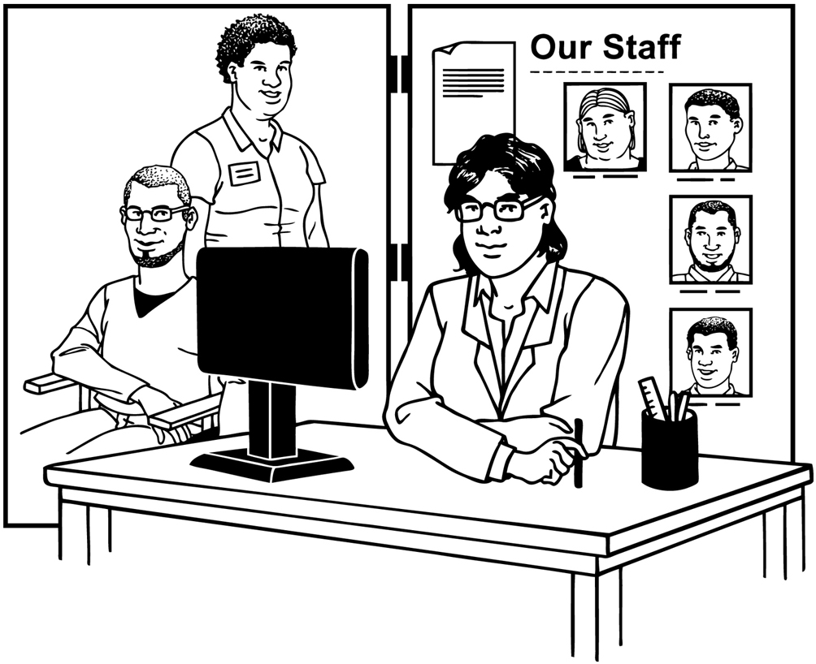   | You can say you are interested in a home in different ways  - By telephone  - By text  - By internet  - By DigiTV  - By post  - At the Property shop or housing office  - A person you choose or a person from the housing office
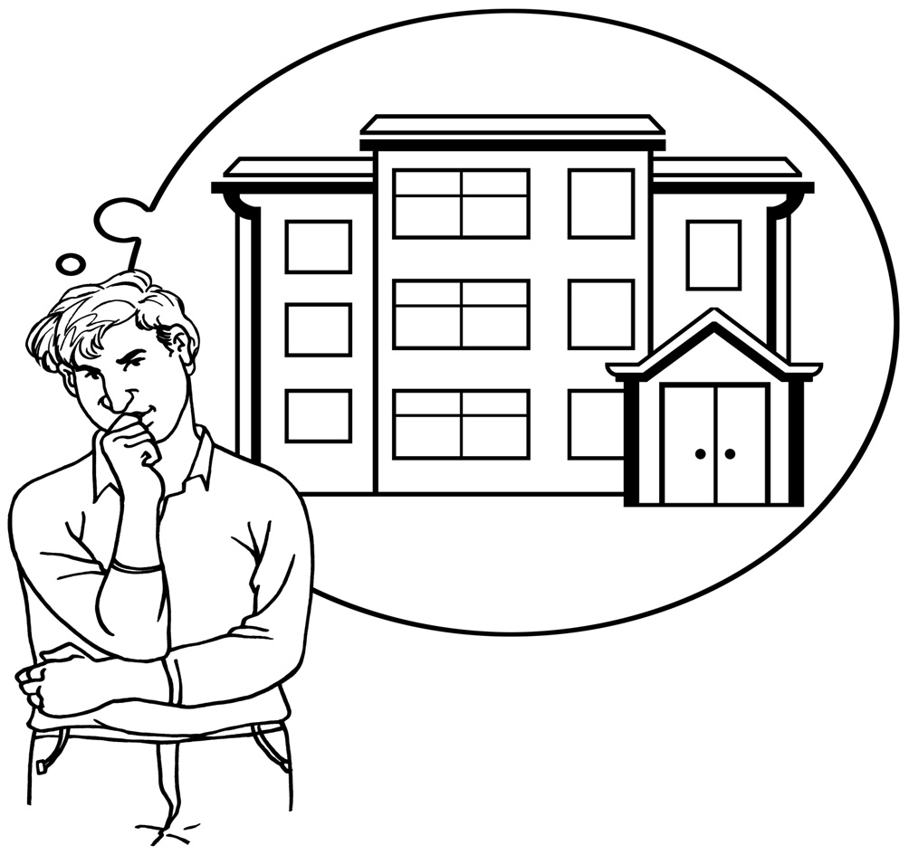 | Getting a home  You may be asked to go and see a home you have chosen  You will be asked to look at the home and see if you want it  It can sometimes take a long time to be asked to see a home  It is important that you keep choosing homes that you like every week  You will be told about the reasons someone else was given the home you wanted like which band they were in and how long they have waited
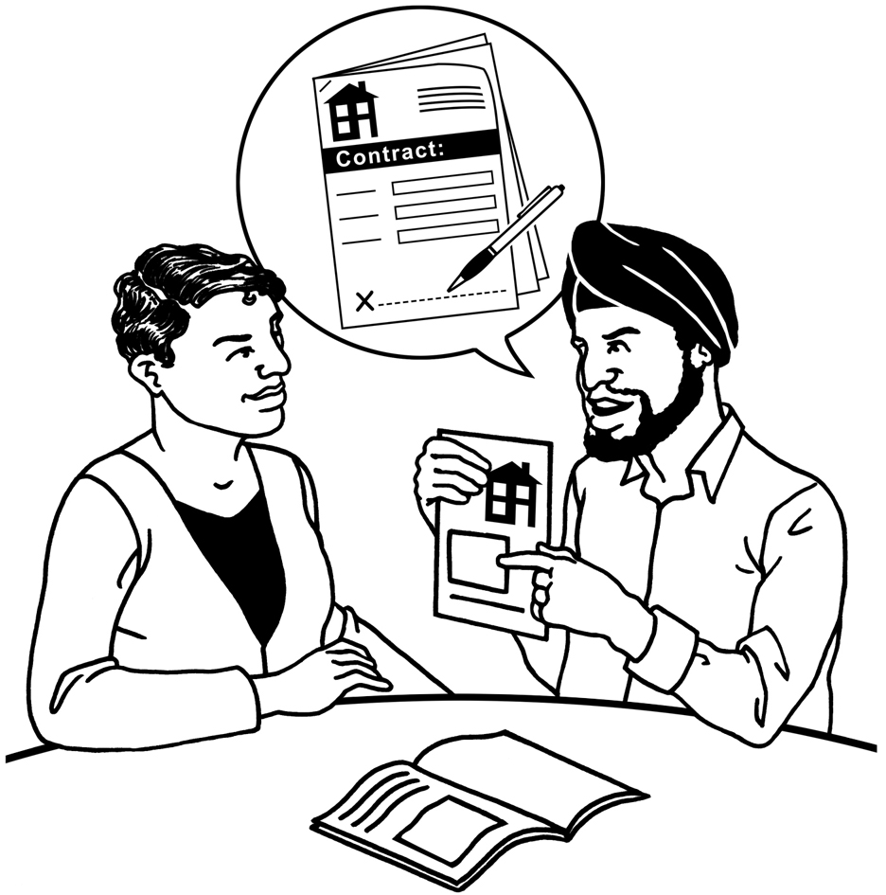  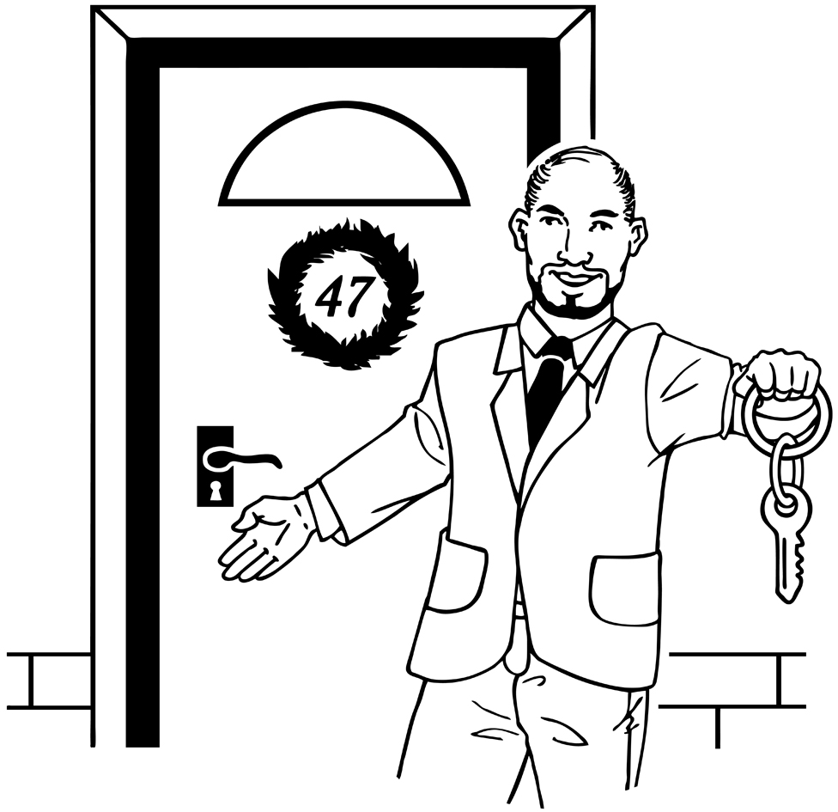 | Agree the rules and get your keys  You will asked to decide whether you want the home you have looked at  You will be asked to agree the rules about having your home –this is called a tenancy agreement  When you agree the rules you will get your keys to your new home
 | Getting help  The Disability Equality Duty says that people with a disability should get extra help from the council to get housing if they need it  You can get help to make the application  You can get help if you are homeless and need a home quickly  You can get help to say which homes you like  You can get housing staff to choose for you  You can get extra time to decide on your home if you need to because of your disability  You can get help with moving and getting furniture  You can get help to look at other ways to get  housing  Ask when you apply for a home
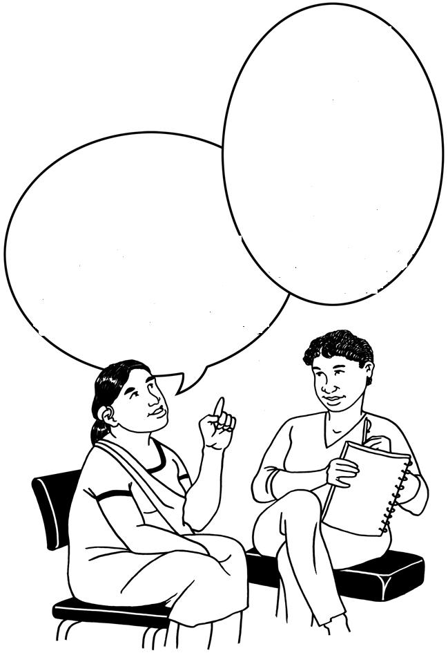    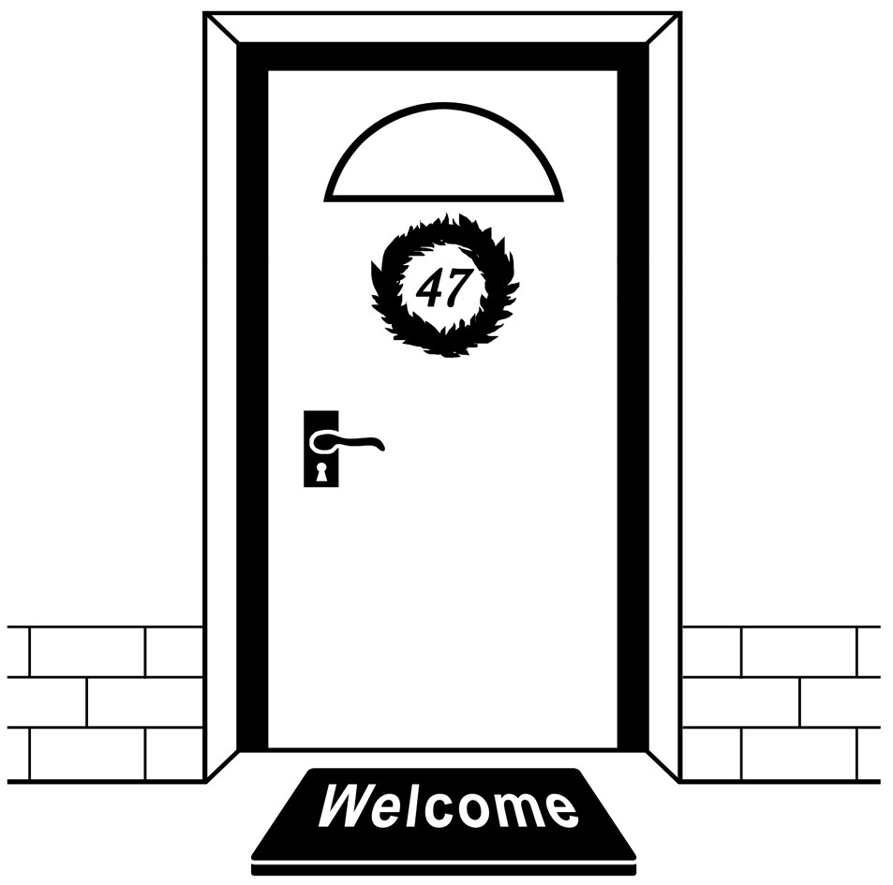 | Some people will also need help from a supporter or family member  The next section is a guide for how a supporter or family member can help

Supporting a person with a learning disability to use Choice Based Lettings
Getting on the housing register
It is important for all people who need housing now or in the future to register their housing need. The housing register is used to help councils and housing associations plan the housing they need to provide and it is important that they are able to plan housing for people with learning disabilities. You can register your housing need and not have to actively look for a home until you are ready. The longer a person has been on the housing register, the easier it is to get a home.
Help with the application

It is important to make sure that the application form is filled out correctly as this will be used to decide on what priority the person has for housing. Many people with a learning disability that need housing live in situations that do not place them in obvious priority need such as in the family home or in residential care or supported housing because they may be considered to be adequately housed.
It is important to make the person’s situation clear in the application, for example:
- Whether the person does or will suffer from mental of physical ill health by remaining in their current home including the effects that a lack of independence can bring
- Whether the person is suffering from any domestic abuse that includes verbal, physical and sexual abuse
- Whether the family or carer can continue to care indefinitely, and whether the carer is older and/or suffers physical or mental ill health or stress because of their caring role.
- Whether it is unreasonable for the person to continue living in their current home for other reasons
The housing department will help with the application form but they will not necessarily ask all the right questions to understand the person’s particular situation. It is important that someone who knows the person well can support them with this part of the process.
Anna had to wait over a year for a new home and she thought that this was unfair. She had a housemate who did not like her and regularly verbally abused her making daily life really difficult for her. Anna’s support worker had helped her fill out the application form and had said that the main reason Anna wanted to move was to be more independent. Anna’s support worker had accepted that this kind of abuse was part and parcel of shared living and did not mention that Anna was suffering from domestic abuse. Had this been put down on the application form, Anna would have had higher priority for housing.

There are lots of ways to bid and the bidding process itself is usually very simple and straightforward. The main role of a supporter will be the following;
Help to bid for homes

- Supporting a person to bid in the way that is best for them or doing it on their behalf
- Making sure that the person gets support to bid by the deadline
- Making sure that the person is bidding for the right kind of homes
- Helping the person to understand what the chances are of being successful in bidding for different types of homes and helping to manage their expectations
- If it is difficult to support the person to bid regularly, making sure they get the right help and finding out where this is provided locally
- You can get housing staff to bid automatically on behalf of a person but it is important to make sure that they are bidding for the type of properties that the person actually wants and needs
Help to look at a home and make decisions

If the person you support is asked to come for a viewing, they are likely to need support in some way;
- To read the letter offering a viewing
- To get to the property
- Help to think through whether the property and location is right
Depending on the level of support the person needs, you should consider the following;
- Asking the CBL scheme to send a copy letter to you or another person who is supporting so that the person can get help to get to the viewing
- Help the person to think about what is important about the home and area they live in before viewing properties. Help them think about what is essential and what they may compromise on so they are more prepared when making a decision
- Get as much information about the property and area before the person goes to view, like going to the area at night and during the day
- Making sure that someone who knows them well can go and view the property with them
- Making sure that they are allowed privacy when talking about how the property works for them and this may mean making clear to the CBL scheme that it is not appropriate to have shared viewings
- If the person needs extra time to make a decision because of their disability such as getting advice from an Occupational Therapist about the property, making sure that the CBL scheme is aware of this.
Entering a tenancy agreement

It is important that the person you are supporting knows what is expected of them and their landlord before they enter into an agreement. Most people with a learning disability can be supported to understand the basics of the tenancy agreement ie. that you need to pay the rent, look after the house and let others around you live peacefully in return for being able to live peacefully in your own home.
Landlords should provide a tenancy that is easy to understand and with symbols and pictures where necessary. You can ask them to do so as part of the Disability Equality Duty.
There are some people with a learning disability who are not able to understand the basics of a tenancy agreement. This in itself should not stop people from getting a home of their own but the following should be taken into consideration;
- Most councils and social landlords accept that housing is a necessity regardless of mental capacity and issue tenancies to people who lack capacity to understand the contract
- A tenancy that is entered into when the landlord knows about the tenants lack of capacity is legal unless challenged. It is unlikely to be challenged unless for example, the rents are considered excessive in a housing benefit claim or the Commission for Social Care Inspection is concerned about whether the tenant is truly exercising their rights as a tenant
- If there is doubt as to whether it is in the person’s best interest to enter into a tenancy agreement, an Independent Mental Capacity Advocate (IMCA) can be appointed to support a decision about whether the tenancy is in the person’s best interest
- A Deputy, such as a family member can be appointed through the Court of Protection to sign on the person’s behalf
Information and advice about other housing options

It can take a long time to get a home through Choice Based Lettings if the person’s housing need is not considered urgent. Sometimes the homes available are not suitable for the person’s particular needs. If the person wants to share with others, there may not be sharing options advertised through this route. You can get information about getting other types of housing. Your Council should tell you about;
- Private renting and what they will do to help you get it
- Low cost home ownership and how mortgages for some people with disabilities are paid using Income Support
- Supported housing
- Extra Care & Sheltered housing

About this guide

This guide was written by Alicia Wood www.hands-on-plans.co.uk , Claire Hall www.clairehall.com & Skills for People Quality Checkers ; Wayne Hooks, Billy Richardson, Suzie Fothergill, Anthony Fothergill & Margaret Purvis qualitycheckers@skillsforpeople.org.uk on behalf of the Valuing People Support Team and the Care Services Improvement Partnership www.valuingpeople.gov.uk

It was written as a result of a report ‘Choice Based Lettings and People with Learning Disabilities, DH 2008’ (link) that said people with learning disabilities, their families and supporters, need to have better information about how Choice Based Lettings works. This report was written by Wendy Perez wendyaccess@hotmail.com, Wayne Hooks qualitycheckers@skillsforpeople.org.uk , Alicia Wood & Claire Hall. An accompanying guide is also available, ‘How to make Choice Based Lettings work for People with Learning Disabilities –A guide for Choice Based Letting Schemes and Landlords’ (link)

Pictures from Change Housing Picture Bank www.changepeople.co.uk




