Annex 2.

Examples of spreadsheets and Bidding Forms

Sheet 1: Scheme address & organisations

Department of Health
Extra Care Housing Fund 2004/2005 Bidding Form
Scheme Name | Test Scheme
Scheme Address | 1, ABC Close Nottingham, NG1 1AA
Social Services Authority | Greenshire County Council | Lead organisation | Test RSL
 |  | Role of organisation | RSL
Address | ABC House, Nottingham NG2 2AA | Address | ABC House, Nottingham NG2 2AA
Contact Name | AN Other | Contact Name | AN Other
Contact Telephone | 123 4567 8900 | Contact Telephone | 123 4567 8900
Contact E-Mail | test@test.com | Contact E-Mail | test@test.com
Organisation 2 | Buildit PLC | Organisation 3 |  | Organisation 4
Role of Organisation | Contractor/developer | Role of Organisation |  | Role of Organisation
Address | Brich House, Brick Lane, Nottingham. NG3 3AA | Address |  | Address
Contact Name | AN othertoo | Contact Name |  | Contact Name
Contact Telephone | 123 456 78900 | Contact Telephone |  | Contact Telephone
Contact E-Mail | build@build.com | Contact E-Mail |  | Contact E-Mail

Sheet 2: scheme details & timescale

Department of Health
Extra Care Housing Fund | 2004/2005 Bidding Form
 |  |  |  | scheme type (select all that apply)
Scheme Name | Test Scheme |  | newbuild | yes
Local Primary Care Trust | Greenshire PCT |  | remodelling | yes
Local Housing Authority | Another District Council |  | other (eg adaptations, communal facilities) | yes
 |  |  | revenue funding required? | yes
 | land and property details |  |  | tenure (select all that apply)
Do you already own the building/land? | yes |  | social rent | yes
If no, then please give the name of the landowner | n/a |  | open market sale | yes
Has the property previously received any public subsidy? | yes - some SHG for existing units |  | shared ownership | yes
Brownfield site? | yes |  | market rent | no
Site area (Ha) | 0.404 |  | intermediate care | no
Gross internal floor area (m2) | 1800 |  | other specify
 |  |  | other non-housing accommodation proposed (please specify) | Homecare agency base: dementia daycare facility
Scheme details and timescales continued. .

 | forecast timescale |  |  | ethnic groups
Site Purchase (if applicable) | Dec-04 |  | group | units
Planning Permission: Outline | Date
Planning Permission: Detailed | Date
 |  |  | white British | 65
Start on site | Mar-05 |  | Asian Other | 10
Practical completion | Jun-06

Scheme type
Enter if this is new build, remodelling or for communal facilities. Indicate all that apply; most schemes will fall into just one category but some will fall into two, perhaps three.

New build: As it suggests. This can be schemes ranging from small rural schemes through to extra care villages.

Remodelling: this is an existing building that may have previously had the support of public sector funding /grant but needs funding for remodelling to make it suitable for the purposes of Extra Care sheltered housing.

Communal Facilities: Bids to upgrade communal facilities of sheltered housing schemes in order that they can shift along the housing continuum to become extra care.

Revenue: indicate amount required

Tenure
For each bid, you should enter tenure type e.g. social rent, market rent, shared ownership, open market sale. For mixed tenure bids (as one example) please indicate all the tenures that apply; however please list the units in each tenure category separately in the unit details sheet.

Social Rent: Schemes that provide permanent housing for rent from Housing Associations, funded partly from grant or other public subsidy and partly from private loans.

Open Market Sale: Leasehold, with restrictive covenants restricting age of owner/occupiers

Shared Ownership: A home-ownership scheme designed to help people who wish to buy a home of their own. It allows people to buy a share of a property and pay a rent on the remainder, although for older peoples’ housing, no rent is payable on the last 25%. An element of the Total Scheme Cost is provided by public subsidy and the balance is raised from a private loan.

Market rent: The market rent is paid by tenants. Similar restrictive covenants regarding age of occupants.

Intermediate Care: bids for intermediate care should be part of a bid for an extra care development (new build, re-modelled or communal facilities). It is the term used to describe a range of short-term rehabilitative services for people leaving hospital, and for people who are at risk of hospital admission. It acts as a bridge between a variety of care settings, including hospitals residential and nursing homes, very sheltered and people’s own homes. Intermediate care usually involves a short programme of support with input from social services and health professionals. Government defines an intermediate care episode as typically lasting no more than 6 weeks.

Land and property details
Indicate if the land is in your ownership, or give details of the landowner. Also indicate if there has been any previous public capital funding for the land and/or building. Give further details in the covering letter if possible.

Brownfield sites
Indicate if any new development is on a site that has been subject to a previous development use

Area of the Site
If the bid is for new build enter the site area in hectares.

Planning permission: Dates of outline and/or detailed planning consents

Gross Internal Floor Area
Enter the Gross Floor Area for the bid including all circulation and communal space and individual flats/units.

Forecast timetable
Please complete this realistically. Guarantees cannot be made to fund schemes that fall outside dates given, particularly if these move between financial years.

Ethnic groups
Please give estimates of the number of units to be occupied by the following ethnic groups:
White – British; Irish; Other White
Mixed - White & Black Caribbean; White and Black African; White & Asian; Other Mixed
Asian or Asian British – Indian; Pakistani; Bangladeshi; Other Asian;
Black or Black British – Caribbean; African; Other Black

Chinese or other ethnic group - Chinese; Other ethnic

Do not know - not known

Sheet 3: unit details

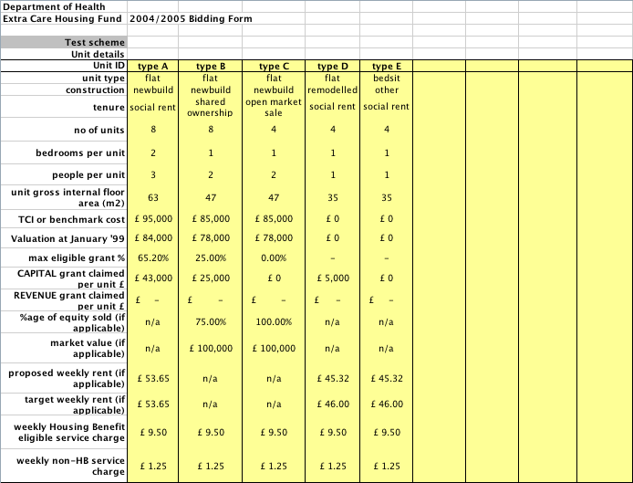

Unit ID: Your description to differentiate between different unit types

Unit type: eg, flat, bungalow

Type of unit: one, two or three bedroom

TCI or benchmark costs: As defined by the latest Housing Corporation procedures in force at the time of bidding. This need not apply for purely leasehold schemes.

Maximum eligible grant: As defined by the latest Housing Corporation procedures in force at the time of bidding.

Grant claimed per unit: Bidders should enter the amount of funding they require from the Department of Health per unit by unit type.
For any form of social housing, bidders should have regard to the relevant Housing Corporation defined Total Scheme Cost, TCI’s or benchmark costs and grant rates, ensuring that the funding required will make the scheme work in the light of their current rent policy.

Percentage of equity sold: If shared ownership or open market sale.

Sheet 4: costs and grant details

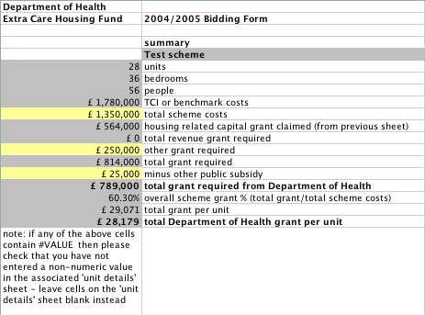

Total Scheme Cost:
You should enter 100% of projected outturn costs including on-costs, in pounds. Note that all bids should be based on projected outturn costs at the price levels you anticipate, not on the appropriate Total Cost Indicator or today’s prices. This is to enable the cost of all competing bids to be compared on a similar basis.

Other grant required:
Include any other grant you require, in addition to that calculated by the Unit details sheet. Details of why the grant is required should be included in your covering letter. Any other subsidy such as a capital contribution or free or cheap land should be excluded from the grant required, as should any input of private support.

Other Public Subsidy
Bidders should enter the details of subsidy that they expect to receive from other public bodies (e.g. Local Authorities) which will count against the grant limit for the scheme. This should clearly identify any free or cheap land that is being made available and any capital contribution from any other public body.

Bids to Upgrade Communal Facilities

Landlord name

Name of scheme/service

Address of scheme/service

Postcode

Scheme tel. no

Scheme/service manager’s name

Name and contact details of person completing this questionnaire

Please answer all questions for each section.

Answer each question in two parts, firstly in relation to the current arrangements and secondly explain any proposed changes as a result of the scheme becoming extra care

Client Groups

Older people
Frail older people
People with dementia
People with mental health problems
People with learning disabilities
People with a physical disability
People with sensory impairment
People with specific needs

- Eligibility Criteria

Tenure types – please provide details?

Policy towards black and other minority groups?

Is your scheme/service specifically for black and other minority groups (please answer YES or NO) and if so please state which group(s)

Are any pets or animals allowed – please provide details?
Referral system and sources?

Are interested applicants able to view scheme prior to applying?

Service, outcome objectives, and style of service

Main purpose, approach and outcome objectives
Please set out the main purpose of the scheme/services and the main outcomes you are trying to achieve.

Specific information on style of work with tenants
Tenant involvement – how are tenants involved?

Community Involvement

Does the scheme/service aim to integrate people into the wider community and if so why and how?
Do people living in the surrounding area have access to some or all of the facilities and/or services of the scheme, and if so how and why?

Does the scheme aim to address social isolation by encouraging friendships and social networks between the residents and local people and if so how and why?

Place Occupied on Sheltered Housing Continuum

Please use the sheltered housing continuum, to place your scheme/service on the continuum (see below)

Sheltered housing continuum
Point 1 | Point 2 | Point 3
TRADITIONAL  Sheltered housing as basic housing provision. Residents are the traditional clientele and they are expected to move on when they are unable to manage | TRANSITIONAL  Sheltered housing as housing and support. The residents are more likely to include former owner occupiers, frailer older people and traditional residents. People are more likely to age in place | SUPPORTING  Sheltered housing as housing, support and as a caring environment. Residents are diverse. The expectation is that they have a home for life, with care and support arrangements agreed with social services and health. There is also an outward focus into the community and sheltered housing is used as a base for service provision and social activities in the local community

Please outline any aims to change where the service will sit on the continuum and how this will be achieved?
What does it feel like from the service user’s perspective to live in the scheme/use the service?

- Buildings and dwellings standards

Elements in the building(s)
Describe the features and elements of the scheme?

Building
Building type and designation e.g. sheltered housing block on 3 stories;
State if purpose built or adapted building
Year scheme built or adapted

Numbers and types of dwelling units (e.g. bedsits; one bed, two bed flats/bungalows)
If there are plans to re-model individual dwellings please provide details including timescales and funding arrangements?

 | Total number  of units and total floor area | How many of these units are wheelchair accessible (wheelchair height kitchen units, bath hoist etc.) | How many of these units are adapted for people with physical disabilities (wider doors ways for zimmers, grab rails)
Total number of bedsits with shared facilities (please specify what is to be shared)
Total number of bedsits with own facilities
Total number of
one bedroom one person units
Total number of
one bedroom two person units
Total number of two bedroom units

Total number of
one bedroom one person
bungalows
Total number of
one bedroom two person bungalows
Total number of two bedroom bungalows
Do you have any units that do not fulfil the above descriptions? If yes what are they

Main entrance and communal areas
Level

Ramp

Steps

Wide doors

How many storeys are there in this scheme

Stair lift

Through floor lift

Security restricted access at main front door

Does the scheme have CCTV?

Communal facilities
Laundry

Lounges (how many)

Kitchen

Hairdressing room

Dining room

Medical Room

Does the scheme have a hearing loop induction system in the communal lounge?

Guest room?

Other communal facilities? please specify

Specialist facilities

Do you offer any facilities for people who have specific cultural or religious requirements? If yes please give details

Car Parking Number of spaces?

Location

Local facilities

Please state the distance of the scheme service from the following facilities. For each please state if: less than 400 yards; less than half mile; less than mile; more than a mile

Distance from BusStop less than 400 yards (10 yrds)
Nearest post office less than 400 yards
GP surgery/health centre less than 400 yards
Shops less than 400 yards
Other
Accessibility of location

Please state if the location is flat or hilly and if there is good access for people with disabilities?

- Services

Services
In column 1 of the table below outline the services DIRECTLY provided and included in your rent/service charge, specifying personal care, healthcare, therapies, housing related support, maintenance services, other services e.g. education; and explaining what times of day and which days of the week provided. State name of service and what service offers

In column 2 outline other services provided indirectly through the scheme/service e.g. visit of healthcare professionals such as dentists / chiropodists / opticians / pharmacists, accessing shopping and cleaning services, welfare benefits advice, and accessible transport

Service | Services provided directly | Services available via others
Help in setting up and maintaining home or tenancy
Developing domestic/skills
Advice, advocacy and liaison
Help in managing finances and benefit claims
Emotional support, counselling and advice
Help in gaining access to other services
Help in establishing social contacts and activities
Supervision and monitoring of health and well-being
Supervising or monitoring medication
Provision of community or social alarms
Help maintaining the safety and security of the dwelling
Cleaning of own rooms
Help with shopping, errand running and good neighbour tasks
Liaison and advocacy support from the same ethnic group
Culture-specific counselling/emotional support
Access to local community organisations
Signposting to culture specific health/treatment services
Personal care
Domiciliary and home care
Health care
Rehabilitation after illness/acquired disability

Staffing

Set out the staffing levels and arrangements for the services directly provided and brokered through other agencies.

