Annex 2.

Examples of spreadsheets and Bidding Forms

Sheet 1: Scheme address & organisations

Department of Health
Extra Care Housing Fund 2007/2008 Bidding Form
Scheme Name | Test Scheme
Scheme Address | 1, ABC Close Nottingham, NG1 1AA
Social Services Authority | Greenshire County Council | Lead organisation | Test RSL
 |  | Role of organisation | RSL
Address | ABC House, Nottingham NG2 2AA | Address | ABC House, Nottingham NG2 2AA
Contact Name | AN Other | Contact Name | AN Other
Contact Telephone | 123 4567 8900 | Contact Telephone | 123 4567 8900
Contact E-Mail | test@test.com | Contact E-Mail | test@test.com
Organisation 2 | Buildit PLC | Organisation 3 |  | Organisation 4
Role of Organisation | Contractor/developer | Role of Organisation |  | Role of Organisation
Address | Brich House, Brick Lane, Nottingham. NG3 3AA | Address |  | Address
Contact Name | AN othertoo | Contact Name |  | Contact Name
Contact Telephone | 123 456 78900 | Contact Telephone |  | Contact Telephone
Contact E-Mail | build@build.com | Contact E-Mail |  | Contact E-Mail

Sheet 2: scheme details & timescale

Department of Health
Extra Care Housing Fund | 2007/2008 Bidding Form
 |  |  |  | scheme type (select all that apply)
Scheme Name | Test Scheme |  | newbuild | yes
Local Primary Care Trust | Greenshire PCT |  | remodelling | yes
Local Housing Authority | Another District Council
 | land and property details |  |  | tenure (select all that apply)
Do you already own the building/land? | yes |  | social rent | yes
If no, then please give the name of the landowner | n/a |  | open market sale | yes
Has the property previously received any public subsidy? | yes - some SHG for existing units |  | shared ownership | yes
Brownfield site? | yes |  | market rent | no
Site area (Ha) | 0.404 |  | intermediate care | no
Gross internal floor area (m2) | 1800 |  | other specify
 |  |  | other non-housing accommodation proposed (please specify) | Homecare agency base: dementia daycare facility
Scheme details and timescales continued. .

 | forecast timescale |  |  | ethnic groups
Site Purchase (if applicable) | Dec-07 |  | group | units
 |  |  | White British | 65
Planning Permission: Outline | Date |  | Asian | 10
 |  |  | Client Focus | Units
Planning Permission: Detailed | Date |  | Older People | 55
 |  |  | Learning disabilities | 8
Start on site | Mar-08 |  | Physical disabilities | 12
Practical completion | Jun-09

Scheme type
Enter if this is new build or remodelling or a mixture. Indicate all that apply; most schemes will fall into just one category but some will fall into both

New build: As it suggests. This can be schemes ranging from small rural schemes through to extra care villages.

Remodelling: this is an existing building that may have previously had the support of public sector funding /grant but needs funding for remodelling to make it suitable for the purposes of Extra Care sheltered housing.

Tenure
For each bid, you should enter tenure type e.g. social rent, market rent, shared ownership, open market sale. For mixed tenure bids (as one example) please indicate all the tenures that apply; however please list the units in each tenure category separately in the unit details sheet.

Social Rent: Schemes that provide permanent housing for rent from Housing Associations, funded partly from grant or other public subsidy and partly from private loans.

Open Market Sale: Leasehold, with restrictive covenants restricting age of owner/occupiers

Shared Ownership: A home-ownership scheme designed to help people who wish to buy a home of their own. It allows people to buy a share of a property and pay a rent on the remainder, although for older peoples’ housing, no rent is payable on the last 25%. An element of the Total Scheme Cost is provided by public subsidy and the balance is raised from a private loan.

Market rent: The market rent is paid by tenants. Similar restrictive covenants regarding age of occupants.

Intermediate Care: bids for intermediate care should be part of a bid for an extra care development (new build or re-modelled). It is the term used to describe a range of short-term rehabilitative services for people leaving hospital, and for people who are at risk of hospital admission. It acts as a bridge between a variety of care settings, including hospitals residential and nursing homes, very sheltered and people’s own homes. Intermediate care usually involves a short programme of support with input from social services and health professionals. Government defines an intermediate care episode as typically lasting no more than 6 weeks.

Land and property details
Indicate if the land is in your ownership, or give details of the landowner. Also indicate if there has been any previous public capital funding for the land and/or building. Give further details in the covering letter if possible.

Brownfield sites
Indicate if any new development is on a site that has been subject to a previous development use

Area of the Site
If the bid is for new build enter the site area in hectares.

Planning permission: Dates of outline and/or detailed planning consents

Gross Internal Floor Area
Enter the Gross Floor Area for the bid including all circulation and communal space and individual flats/units.

Forecast timetable
Please complete this realistically. Guarantees cannot be made to fund schemes that fall outside dates given, particularly if these move between financial years.

Ethnic or other ethnic group – eg Chinese; Other ethnic
Please give estimates of the number of units to be occupied by the following ethnic groups:
White – British; Irish; Other White
Mixed - White & Black Caribbean; White and Black African; White & Asian; Other Mixed
Asian or Asian British – Indian; Pakistani; Bangladeshi; Other Asian;
Black or Black British – Caribbean; African; Other Black

Other group – eg learning disability; other

Do not know - not known

Client Focus

Please describe how many units will be provided for older people, people with learning disabilities, people with physical disabilities, people with mental health problems and people with dementia or other client focus.

Sheet 3: unit details

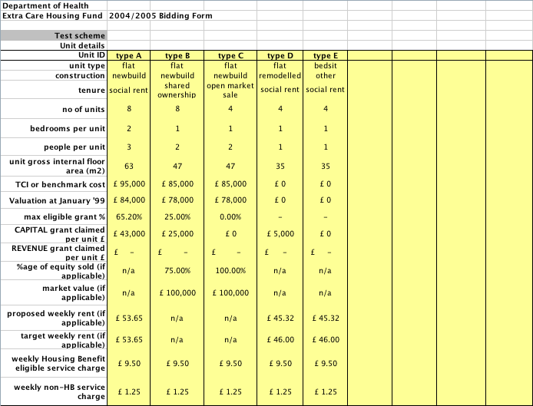

Unit ID: Your description to differentiate between different unit types

Unit type: eg, flat, bungalow

Type of unit: one, two or three bedroom

TCI or benchmark costs: As defined by the latest Housing Corporation procedures in force at the time of bidding. This need not apply for purely leasehold schemes.

Maximum eligible grant: As defined by the latest Housing Corporation procedures in force at the time of bidding.

Grant claimed per unit: Bidders should enter the amount of funding they require from the Department of Health per unit by unit type.
For any form of social housing, bidders should have regard to the relevant Housing Corporation defined Total Scheme Cost, TCI’s or benchmark costs and grant rates, ensuring that the funding required will make the scheme work in the light of their current rent policy.

Percentage of equity sold: If shared ownership or open market sale.

Sheet 4: costs and grant details

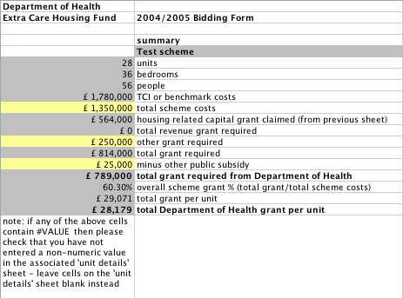

Total Scheme Cost:
You should enter 100% of projected outturn costs including on-costs, in pounds. Note that all bids should be based on projected outturn costs at the price levels you anticipate, not on the appropriate Total Cost Indicator or today’s prices. This is to enable the cost of all competing bids to be compared on a similar basis.

Other grant required:
Include any other grant you require, in addition to that calculated by the Unit details sheet. Details of why the grant is required should be included in your covering letter. Any other subsidy such as a capital contribution or free or discounted land should be excluded from the grant required, as should any input of private support.

Other Public Subsidy
Bidders should enter the details of subsidy that they expect to receive from other public bodies (e.g. Local Authorities) which will count against the grant limit for the scheme. This should clearly identify any free or discounted land that is being made available and any capital contribution from any other public body.

