Example of Practice – River Clyde Homes
Extra Care Team - Sustaining wellbeing, sustaining relationships, sustaining tenancies

Context
This practice example is one in a short series illustrating how initiatives and extra services run by Housing Associations have a significant positive impact directly or indirectly on the quality of life, health and well-being of those people being supported.

Setting
Operating in the Inverclyde area, River Clyde Homes is amongst the largest of Scotland’s social housing providers, with circa 5600 homes. It has created an Extra Care Team that provides a wide range of support and resources to new and established tenants.

What is the issue being addressed?
One of River Clyde Homes’ seven main strategic outcomes is to have, ‘safer and better supported customers’ and, like all social housing providers, it also has a vested interest in sustaining tenancies. The Extra Care team’s activities are designed to further these interrelated objectives. The team has identified a whole range of supportive activities most of which are targeted at more vulnerable tenants. The connection between these activities and health and/ or well-being is not always immediately obvious, but nevertheless exist.
This practice example shows the range of supports provided and looks at the impact of these on its tenants.

What is happening?
Extra Care support is available to all tenants, new and existing. Funding has also been secured from Scottish Legal Aid and the People and Community Fund to provide additional resource to new tenants for the first 12 months of their tenancy (Extra Care Plus).
The Extra Care Team (including Extra Care Plus) comprises 9 Full Time equivalent staff members: Extra Care Officers, Welfare Benefits Officer, Extra Care Manager, and two officers dedicated to Sheltered Housing. The Extra Care Plus component of the team is now in its second year of operation and is delivered through two full-time posts.
Extra Care Service - The main characteristics of the service are outlined in the table below:
Key features of Support and Initiatives | What is provided | Impact
Warm welcome, secure start | Early contact with team and information about Extra Care services as soon as person displays interest in getting accommodation with River Clyde Homes  Starter/Welcome Packs with a monetary value of around £150 each are available if required. A Starter Pack may include (depending on need): crockery pack, pot pack, Utilities pack, Hygiene pack, Bedding packs, Breakfast pack.  Open door policy – walk in/no appointment required to access Extra Care support. | Establishes a personal relationship, builds trust and confidence, which means that tenants more readily connect with organisation if and when they need help and support.  Displays warmth and regard for new tenant (important for sense of well-being), as well as providing practical assistance.  Increases opportunity for and likelihood of people coming in to seek help with issues.
Promoting financial security/stability | Dedicated Welfare Benefits Officer post within team provides:  The Welfare Benefits team offers welfare benefits advice to River Clyde Homes’ Tenants. The advice is free and confidential and an appointment is not always necessary. Visits can be at home or in the office at times convenient to the tenant.  The main areas that support is offered in are:  - Maximising entitlement to benefits (in particular Housing Benefit). This could be by helping individuals apply for additional benefits or by making sure that they are getting the right amount of a benefit already being received.  - Completing benefit forms for tenants (on-line, paper or phone applications).  - Offering support and advice to make a right decision of what benefit to claim.  - Completing changes of circumstances paperwork  - Helping people to comply with all DWP, HMRC or Inverclyde Council demands so that they don’t find themselves in a position of being sanctioned or cut off.  - Helping people to understand any letters that they receive regarding benefits and assisting with responses if required.  - Challenge or submit reconsiderations and written appeals to the relevant body if it is believed that a wrong decision has been made.  - Providing support with applications to the Scottish Welfare Fund.  - Speaking on behalf of the tenant to other organisations to solve problems or challenge decisions. For example Inverclyde Council, DWP, HMRC.  - Providing detailed financial assessments, evaluating any debts and providing bespoke advice on the best course of action.  - Signposting to and mediating with other organisations that may be able to provide additional support.  - Dealing with letters about benefits including suspensions or cancellations. | Reduces poverty, inequality and financial worries as much as possible – all factors which impact significantly on health and well-being.
Integrated approach*  *See also example of integrated approach below | Extensive links and liaison relationships with:  - Inverclyde Homelessness Team  - Occupational Therapy  - Welfare Rights  - Credit Union  - Energy Advice  - Fire Scotland  - Social Work  Aids and adaptations service and budget delivered by RCH | Makes access to additional resources easier.  Positive inter-agency work with homelessness team encourages early referrals.  Improved home comfort and safety.  Allowing people to live longer and better lives in their own home.
Targeted Support | Available to all tenants based on need.  Referral system via Centre for Independent Living for major adaptations such as stair lifts, ramps, wet floor areas.  Self referral form for minor adaptations such as grab rails, handrails, flashing beacons, sliding doors.  Winter Wellbeing Campaign aimed at tenants aged 75 plus, involved:  - Personal visit  - Provision of pack of useful items such as blankets, torch and ‘token’ food items, etc.  - Information on community resources/ activities, social networks, how to keep warm, home safety, etc.  - Well-being check and referral system to address needs | Early detection of issues or difficulties.  Helps establish stability and security.  Tenants feel valued  Health and wellbeing issues are detected and can be addressed such as:  - Isolation  - Nutrition  - Medical concerns  - Aids and Adaptations  - Repairs  - Benefits, money advice  - Fuel advice  - Future Skills

Integrated Approach – Example
The integrated approach was exemplified recently when one of the older tenants needed an adaptation to their home. The adaptation centred on the fitting of a wet room, but the wider picture was that the team needed to ensure multi-agency co-ordination to arrange OT assessment, temporary accommodation, home care and the provision of meals to achieve the outcome of enabling this person to remain in their home.

Winter Wellbeing 2015
Around 800 older people received packs and a winter wellbeing check that covered a range of issues. People are given details of social contact opportunities to help reduce the risk of isolation along with information on carers support, SAFFA and are asked if they need extra care with medication and nutrition. However, requests for referrals to address these aspects of wellbeing are rare (around 1% of all the follow up actions). It is other aspects of the well-being check that lead to further assistance being provided. Notably, providing affordable warmth, keeping safe and help with diminishing mobility such adaptations to assist getting in or put the bath or shower. The chart to the left summarises the nature of 345 requests/referrals coming out of the well-being visits:
Winter Wellbeing 2015 – Around 750 older people received packs and home check - of these around 50% requested assistance as follows: repairs 25%, fuel poverty 33%, Aids & Adapts 12%, Debts/ benefits advice 8%, Fire safety 18%, Future Skills 3%.

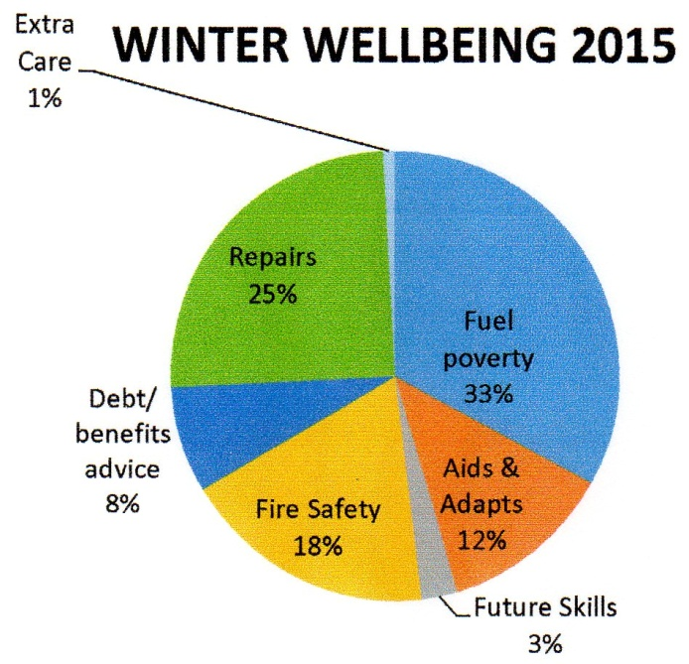
Other Outcomes
River Clyde Homes has been able to access People and Communities and Scottish Legal Aid Board funding of approx. £200k for an 18 month project for Making Advice Work. In turn, this has enabled staff to secure, on behalf of tenants, an additional income in excess of £1.4m over the last financial year, by maximising tenants’ income through Housing Benefit, Council Tax Reduction, JSA, Income Support, ESA, and Tax Credits. This sum also included Scottish Welfare Fund community care and crisis grants.
There were 609 new tenancies created in 2014/15 and there was a failure rate of 2%, this is a reduction on previous year when there were no dedicated extra care staff.

Contacts - To find out more
Jane Wallace, Extra Care Manager jane.wallace@riverclydehomes.org.uk Tel: 01475 788 845

