Housing LIN Eastern Region Meeting July 9th Hoddesdon

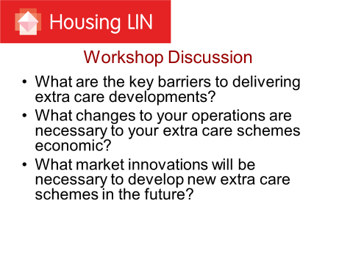

 | Barriers | Changes | Opportunities
Group 1 | land availability  right locations, right cost large enough plots close to the community  Opportunities to bring in extra care to pioneer communities  Finance, lack of capital and uncertainty of revenue funding  No agreed method of operating, some providers wish to provide care, some do not  Lack of perception on what extra care is. No constant concept. - Wrong name, change to Housing with care. | Colocation with other services eg pharmacy, hairdresser, shop open to the whole community with residents fully on board  Larger number of homes to meet infrastructure cost  Move to community hub can take pressure off unit numbers  Share more information between providers. Issue of competition v collaboration  Mixed tenure and try before you buy  Help to move service | Help to move downsizing service  Involve residents early in the process  Potential to provide more general services eg Home from Hospital  Stepping Stones , temporary accommodation to help discharge/reablement  Respite Care  Housing advice and information service linked to Care Act repsonsibilities  Shared locality with GPs and adult care for housing advice  Alternate investment for outright owners
Group 2 | Finding sites in right places  Need to convince eplanners  Size viability refurb/convert  Revenue  Care Costs  Split commissioning issue  Tenure - intro market sale  - cross subsidy  Extra Care more capital hungry than general needs. Therefore about HA/LA priorities  Hidden benefits of extra care – revenue savings releasing gen needs accommodation  Dementia friendly design + timing  Non alignment of housing and care provider objectives  Benefit of one provider for both  CQC cost and set up  5 year care contracts | Joint commissioning  Engagement and need/demand  Better understanding of and training in benefits of ECH  Focus on individual personal needs  Further develop Home First model of multi disciplinary rapid response teams.  Training on dementia high needs  Prohibitive residential care costs, lack of beds  Need for more robust move on assessment | Telecare, Telehealth  Modular build to reduce capital costs  Community based model – Shop Café Dr’s surgery
Group 3 | Range of options needed  Right people living there, correct assessment and allocation process. Ie in need of care provision  Expensive to build and maintain  Scale  Challenge of those who need care and those looking or independence  ? Better option HAPPI standard gen needs housing  Affordability issues  Choices made later in life  Design management issues  Community coming in - change in operation tenancy agreement | Modern fit for purpose design  Flexible accommodation to meet changing needs  Work across two tier authorities. | Marketing issue – persuading to move at right time  Social workers “warming up “ people to move  Upgrade and refurb to provide community hub. Use social capital. Use direct payments to support communities helping themselves.  Care Act emphasis  Wellbeing development – role of RPs and vol sector.  New relationship of care sector with housing authorities.

Group1
Barriers
Changes to Operation

Innovations

