Halton Court (Kidbrooke Village)
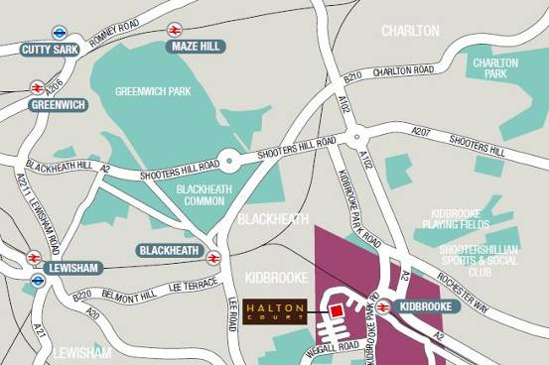

Location
Kidbrooke Village is conveniently located off the A2 Sidcup by-pass, giving quick and easy access to the M25 and M2. Travelling north of the river is also very convenient with the Blackwall Tunnel being just under one mile away to the north. Halton Court is located in the Blackheath Quarter sector of Kidbrooke village, under a mile from Blackheath Village and an approximate 300 metre flat walk to Kidbrooke station and bus stand. From the station Lewisham and the DLR interchange is just six minutes away by train; London Bridge just 15 minutes. Bus services are currently frequent, and provide services across south east London to destinations such as Woolwich, Charlton and Greenwich.
The Village Hall is shown on the Site Plan below (no.1), is accessed through the scheme's main entrance (no.12). There is a staffed reception who will be able to direct you on arrival.
