

Barnwood Trust

Manor Gardens Development, Gloucester

Care and Support Partner Selection

Expression of Interest Pack

4th August 2016

Introduction

Barnwood Trust intends to renew and develop the buildings and land at Manor Gardens, Gloucester over the next 5 years as part of its strategy You’re Welcome (see below). It will provide a mixed tenure, non-specialist but care-ready setting where people with disabilities and mental health needs and those with none, live in a supportive and inclusive environment. Although plans are not finalised, we expect that there will be around 75 -100 units of housing on the site, including a mix of 1-, 2- and 3-bed properties. An aerial view of the current site is shown at Annex 1.

The Trust wishes to appoint a care or a care and support partner to work with them to achieve that vision, i.e. the Trust is flexible about whether a partner is interested in providing care or care and support.

The Trust is seeking a partner that will be able to provide care or care and support to current residents of Manor Gardens as necessary as well as future residents and individuals living in the surrounding neighbourhood who may need care and support. The Trust believes that there are significant advantages from identifying a care or care and support partner at this stage in the development of Manor Gardens, so they can build relationships with the Trust and with current residents.

You can find more information about Barnwood Trust and You’re Welcome at
http://barnwoodtrust.org/
http://www.yourewelcome.to/

The Vision for Manor Gardens

The Trust wants to develop Manor Gardens as an embodiment of its You’re Welcome strategy. This is based on some core ideas:

- Start with people’s strengths: everyone has something they care about and something to offer;
- Strong communities are essential for a good life, and include everyone from the beginning;
- Doing things together helps people to break down barriers, build confidence and seize new opportunities;
- We should focus on what’s strong, not what’s wrong.
You’re Welcome is about creating welcoming and inclusive neighbourhoods where everyone, including people living with disabilities and mental health challenges:

- has friends nearby and knows someone they can have a cup of tea with or call on if they need a hand;
- has enjoyable things to do with others;
- has the confidence to join in communal activities because they know that they’ll be welcome;
- experiences the support and kindness between people that makes life meaningful; and
- is able to contribute what they can offer rather than feeling limited by what they are unable to do.
The Trust is committed to the principles of co-production and intends to involve the current residents of Manor Gardens, some of whom have care and support needs and some of whom have none, in the selection of partners, the design of new and refurbished housing and in the design, development and delivery of care and support services. As the development of both housing and care proceed, the intention is that this will include new residents of Manor Gardens and those from the surrounding neighbourhood who want a care and support service.

Social sustainability is at the heart of Barnwood Trust’s vision. The Trust aims to build the community at Manor Gardens alongside improving the housing and other buildings on site and is investing in that process both on site and in the surrounding neighbourhood.

The Manor Gardens community will:

- be mixed in terms of needs, with people who have care and support needs and people who have none;
- include a range of households; families, couples, single person households and potentially some shared housing; and
- be a community made up of people who support each other where those who need to are enabled to co-produce the care and support they need.
The development will:

- not be a specialist ‘scheme’ but will have spaces which promote connection and allow necessary services to operate for those who need them;
- integrate better with the wider Barnwood and Hucclecote communities; and
- be capable of being replicated elsewhere.
The housing will be:

- mixed tenure incorporating homes for rent, shared ownership and sale;
- high quality and to Lifetime Homes Standard;
- environmentally sustainable; and
- ‘care ready’ but not designated as ‘supported’ (unless changes in welfare policy dictate that this is unavoidable).
The care and support will be:
- co-produced with those receiving care and support;
- strengths-based and linked to the community building process;
- locally based, flexible and good quality;
- offer continuity of personnel;
- offer personal choice and give control to residents;
- be able to support people with a range of disabilities.
There is an existing community living at Manor Gardens and all of the existing residents will be able to remain on the site if they wish.

Context: Profile of Manor Gardens

Current residents

There are currently 46, 1-and 2-bedroomed properties at the Manor Gardens site including 5 bungalows at Newstead Road. At June 2016, four properties were void (held as such specifically to allow for the redevelopment process).

The development plans for Manor Gardens envisage up to 90 dwellings on the site (subject to planning consent) with clear potential for growth in the number of people who have care and support needs living at Manor Gardens as well as from individuals living in the surrounding neighbourhood.

We have profile data about 45 of the existing residents as at January 2016. There were 7 couples and the remainder were occupied by single people. The current formal care hours within Manor Gardens are relatively low: 4 tenants were receiving full care packages (i.e. 3 visits a day) and two receiving smaller care packages (e.g. several hours a week). These packages are delivered by different external care agencies. There are a further four residents who receive regular (daily or nearly daily) care from family; many of the couples are supporting each other.

However, there is a high proportion of current tenants with a disability or other health condition (only half a dozen tenants have neither) and most receive low level support from the existing on-site manager who is employed by the housing association that currently manages the properties on behalf of the Trust. The following charts give an indication of the age and health profile of the current resident population:

Profile of the surrounding area: Barnwood and Hucclecote

The following evidence from the 2011 Census demonstrates that this area could potentially be conducive to a care provider wishing to market their services to self-funders.

In 2011 Barnwood and Hucclecote (B&H) had a population of 11,600, living in 4,970 households.

In 2011 Barnwood & Hucclecote contained 5,145 residential dwellings. 83.5% of properties were owner occupied, which was higher than the county average of 69.4% of properties. According to the overall Index of Multiple Deprivation, six of Barnwood & Hucclecote’s Lower Layer Super Output Areas are amongst the least deprived 20% in England; i.e. this is an area of relatively low levels of deprivation. In Barnwood & Hucclecote, the largest proportion of residents are classified as ‘Comfortable communities’ (ACORN classifications). This means they are typically owner occupiers of average value properties with average incomes and average levels of educational qualifications.

In 2011 the number of people with a long-term limiting illness or disability was 2,085; 18% of the population, higher than the county average of 16.7%. The number of residents with a long term limiting illness or disability increased by 7.2% since 2001.

The proportion of people aged 65 and over was higher in Barnwood & Hucclecote than the county as a whole. In 2011 there were 2,625 people in this age group, living in the area.

There were 780 households occupied by a person aged 65+ living alone, which accounts for 15.7% of total households. This was higher than the county average of 13.2%.

There were 1,390 people in the area that provided unpaid care, this equates to 12.0% of the total population. This was higher than the county average of 10.4%.

In summary Barnwood and Hucclecote is a neighbourhood characterised by:

- Relatively low levels of deprivation;
- High levels of home ownership;
- An increasing population of people aged 65 years and over;
- The number of people providing unpaid care is in the top 35% by area for Gloucestershire;
- A raising and a higher percentage of the population compared to Gloucestershire who have a long-term limiting illness or disability.

Care and Support at Manor Gardens

The approach to care and support at Manor Gardens is intended to be highly innovative and to act as an ‘exemplar’.

The Trust’s wants the care and support services to:

- be co-produced with those receiving care and support, as far as possible. Over time residents may exercise direct control over the care and support arrangements but with professional management services to support them in dealing with the workload associated with employing staff and dealing with regulatory issues, administration and training;
- adopt a strength-based approach, building on the strengths and interests of residents and their capacity for mutual and reciprocal support and connecting them with networks of support in the local neighbourhood.
- be locally based, flexible and good quality;
- offer continuity of personnel facilitating and delivering care;
- offer personal choice and give control to residents;
- be available to other people in the surrounding neighbourhood.
Such an approach would have advantages over a standard domiciliary care service in its potential for flexibility, quality of service, continuity of personnel, personal choice and control. It would have advantages over a conventional extra care model in its linkages with the local community, in not being perceived as a specialist scheme or institution and in keeping service charges relatively low.

Whilst the service would be centred on Manor Gardens, we anticipate that it would also be available to other people in the neighbourhoods of Barnwood and Hucclecote. For individuals who are eligible for care funding from Gloucestershire County Council this will depend on securing agreement for an ‘Individual Service Fund’ model operating at Manor Gardens or individuals opting to take a direct payment and choosing to use it with the care/support provider at Manor Gardens. Others may choose to self-fund.

Making sure that any care and support model developed on the Manor Gardens site fits with and supports the principles of the You’re Welcome strategy is a key priority for the Trust. The following considerations are key for any care and support model at Manor Gardens if it is to support the You’re Welcome philosophy and offer something different from more ‘traditional’ approaches to providing care and support:

- It’s about finding a structure which brings members of the Manor Gardens and surrounding neighbourhood together to give and receive the care and support they want and need;
- The focus should be on what people can offer, what they care about, what they like doing; rather than on what’s wrong and what they need;
- People should have voice, choice and control about how they receive care and support;
- Everyone – including those who receive care – should have the opportunity to make a contribution, in a variety of ways;
- Care and support is not just about meeting basic physical needs; it’s about giving people the confidence they need to do the things that matter to them;
- Any care and support ‘model’ needs to break down the barriers between those who receive care and those who don’t: it’s about connecting people to the wider community, not creating a separate group.
A care and support partner organisation will need to be able to demonstrate that it can deliver this type of approach in practice with existing residents, future residents and people living in the wider local community. The Trust is already investing in community building in the neighbourhood (and elsewhere in the county) and this will complement the approach to care and support.

It is envisaged that the Trust will work with an established provider to apply co-production and strength based principles from the start and gradually hand-over more control over decision making, management and governance to those receiving the service. To date we have held initial conversations with a small group of residents about this type of approach; a care partner would be expected to take these discussions with residents further.

Funding

Residents who receive care at Manor Gardens are in most cases eligible for funding from Gloucestershire County Council. It is anticipated that a care and support partner will be able to work with individuals who are eligible for local authority funded care and self-funders.

The care and support partner will need to be able to accommodate individuals who are eligible for local authority funded care and opt to take their funding allocation through a direct payment.

The Trust is currently in discussion with Gloucestershire County Council in relation to the Council’s potential approach to Individual Service Funds (ISFs). ISFs offer an option for people who want more flexible support, but who do not wish to have the responsibilities that come with a direct payment. They also provide an option for those people who lack legal capacity. An ISF is an arrangement whereby the Council pays money to a service provider in respect of a specific service user and the provider then manages the funding on behalf of that individual.

The care and support partner will need to be able to work with the Trust to establish an ISF approach for residents at Manor Gardens.

The Trust is willing to help resource the initial investment of time required to enable people to co-design and co-produce their care; and to help work with individuals with personal budgets on administrative arrangements to pool their funds and to develop mutual support networks.

Potential roles of other partners

The exact roles and relationships of the delivery partners at Manor Gardens is still to be finalised. However, the following information may provide helpful context as you consider possible partnerships, boundaries and options to add value, engage local residents and promote financial viability.

There will be a housing provider, who will be responsible for the housing management of the scheme. The selection process for this partner is nearly complete.

The housing association which currently manages Manor Gardens employs an on-site manager for the scheme, who provides housing management and some low level support to tenants.

Barnwood Trust has recently appointed a trainee Community Builder who lives in the Barnwood and Hucclecote area and will be undertaking community building work in the surrounding area over the coming months/ years. ‘Community building’ follows an asset-based community development approach and aims to engage with people in the community and link them to others with similar interests and concerns.

Partner Selection

The Trust is keen to work with a care/support partner that is interested in the concept of the development, can demonstrate that they can provide good value and responsive services and have:

- An open-minded and flexible approach;
- Good care and support service delivery credentials;
- A commitment to developing innovative care and support services;
- An understanding of co-production and strengths based practice in relation to care and support.
The Trust’s motivation in renewing the site at Manor Gardens is to show that it is possible to develop housing as part of a community which embodies You’re Welcome and an exemplary approach to care and support is a core part of delivering that vision.

During the selection process, great weight will be placed on choosing a partner that understands the vision and can demonstrate that they would work creatively with the Trust to help to develop the vision for Manor Gardens.

The Trust recognises that was is being asked for is a highly innovative approach to care and support. At this stage the Trust is seeking a dialogue with potential partners so please do not off submitting a response to the Expression of Interest if you are not in a position answer all the questions fully at this stage.

Before you consider submitting this Expression of Interest the Trust or its advisors would welcome the opportunity to discuss this with you further and to answer any questions that you may have.

The Trust’s advisors, Imogen Blood and Ian Copeman, can be contacted at:

Imogen Blood at Imogen Blood & Associates
Email: imogen@imogenblood.co.uk
Telephone: 0161 222 8628/07866 631411

Ian Copeman at Housing & Support Partnership
Email: ian.copeman@housingandsupport.co.uk
Telephone: 07894 904355

If you wish to submit a formal expression of interest in working with the Trust as the care/support partner as part of the development of Manor Gardens please could you answer the questions below entitled ‘Manor Gardens Care and Support Partner: Expressions of Interest’ and return this document with your responses by email to:

Lawrence Miller at Barnwood Trust lawrence.miller@barnwoodtrust.org

by 5pm Tuesday 13th September 2016

The selection process will be:

- Return of Expressions of Interest Tuesday 13th September.
- Shortlisted potential care/support partners will be confirmed by Wednesday 21st September.
- Interviews with shortlisted potential care/support partners will be held on 27th September.
- Period of ongoing dialogue (if required) 28th September – 19th October 2016.
- Selected care/support partner confirmed no later than w/c 24th October.

Manor Gardens Care and Support Partner: Expressions of Interest

Organisational details

Organisation name

Address

Website

CQC registration number

Lead contact

Role

Telephone number

Mobile number

Email address

Questions. Part A

Q1 | Do you provide care (‘regulated activity)? If yes, what types of care services do you provide?
A1
Q2 | Who do your care services cater for?
A2
Q3 | What is your geographical area of operation?
A3
Q4 | How many people do you provide care to and how many hours of care per week as at 31/07/16?
A4
Q5 | How long for have you been providing care services?
A5
Q6 | Do you provide support services (non-regulated activity)? If yes, what does this consist of and for whom?
A6

Questions. Part B

Q1 | Please give us an overview of your ideas (and this may involve a number of options) of how would you foster and develop an exemplar approach to care and support, whilst ensuring financial viability within existing, more ‘traditional’ approaches to the funding of care and support?
A1
Q2 | What is your understanding of You’re Welcome and how would you apply this approach to care and support?
A2
Q3 | How might you go about promoting local ownership and leadership of the care and support at Manor Gardens? How might you expect your role and that of local residents to evolve over time?
A3
Q4 | What levels of care do you assess would be necessary to achieve financial sustainability?
A4
Q5 | How would you ensure a balance between a co-produced approach to care and compliance with relevant regulatory requirements?
A5
Q6 | How might you work in partnership with those providing housing management, support and community building activities?
A6
Q7 | Can you set out your outline funding model for a co-produced approach to care at Manor Gardens?  The Trust recognises that this maybe tentative at this stage. What assistance and support, financial and non-financial, do you think you would require from Barnwood Trust to make your proposed approach at least initially, and for how long?
A7

Annexe 1. Aerial photograph of Manor Gardens site

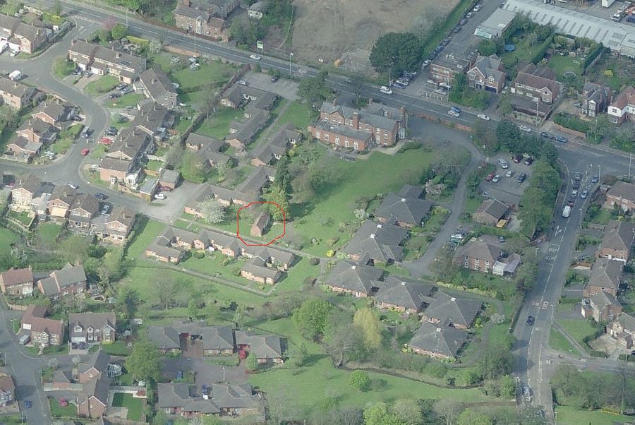
Site boundary:
23 One bedroom bungalows and communal room
Wheatstone – leased to NHS
Workshop/store
Barnwood Road
Manor House: Former day centre and offices (listed)
North Upton Lane
Newstead Road: 5 bungalows: wheelchair adapted for families with a disabled family member
18 two- bedroom bungalows

Manor Gardens is located in Barnwood Road, Barnwood, Gloucester, GL4 3JX

