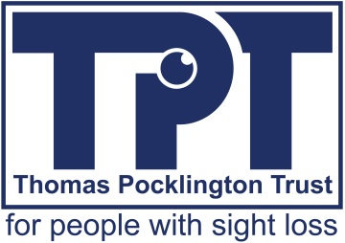

LAUNCH OF ONLINE HOUSING GUIDE FOR VISUALLY IMPAIRED PEOPLE LOOKING FOR A NEW HOME
Tuesday 11th July 2017
For Immediate Release

Leading sight loss charity Thomas Pocklington Trust (TPT) (1) has developed an innovative online housing guide designed to assist younger adults with visual impairment find a new home.
The Housing guide for people with sight loss (2) – launched today – provides information and advice for visually impaired people who are looking for a new home, seeking to live independently for the first time or experiencing problems in their current accommodation.
It covers everything from student housing and tips for living in a shared house to the moving process, assistive technology and support for living independently and more.
The guide, funded by TPT and written by researchers Imogen Blood, Dianne Theakstone and Ian Copeman, is the result of a study on housing advice for younger adults with sight loss, which found there were many resources available online but that it was hard to find the information and there was a lack of peer advice. The guide was developed to bring all this information together in one easy-to-access location.
It was co-produced with people with sight loss and shares personal experiences of visually impaired people who have different life circumstances, provides useful suggestions and signposts to over 100 sources for further advice.
TPT has also conducted a wider project on housing which includes two other research reports: ‘Housing and Independent Living: Synthesis of scoping research for Thomas Pocklington Trust’; (3) and ‘Evaluation of a Housing Brokerage Scheme for younger adults with visual impairment’ (4).
Dr Lynn Watson, Head of Research at Thomas Pocklington Trust, commented: “We wanted to develop a tool that would enable younger adults with sight loss to find information themselves and empower them to live independently when looking to change their living circumstances. The tool will also be a useful resource to any housing organisation, authority or support service involved in helping a visually impaired person to find a suitable home.”
Imogen Blood, Director of Imogen Blood & Associates, commented: “We have developed a single portal where links to all of the up-to-date information have been brought together in one place, along with housing-related peer advice, including podcasts in which people with sight loss give advice on different housing situations they have been in. Working together with younger adults with sight loss gave us a really useful insight we have integrated into each section of the guide.”

You can find the Housing guide for people with sight loss here.

For more information please email: research@pocklington-trust.org.uk

Notes to editors:
- Thomas Pocklington Trust is a national charity for people with sight loss. Its research programme commissions and funds social and public health research initiatives to identify ways to improve the lives of people with sight loss. www.pocklington-trust.org.uk
- The online guide is here: Housing guide for people with sight loss
- The synthesis report is here: Housing and Independent Living: Synthesis of scoping research for Thomas Pocklington Trust
- The evaluation is here: Evaluation of a Housing Brokerage Scheme for younger adults with visual impairment
End of document.

